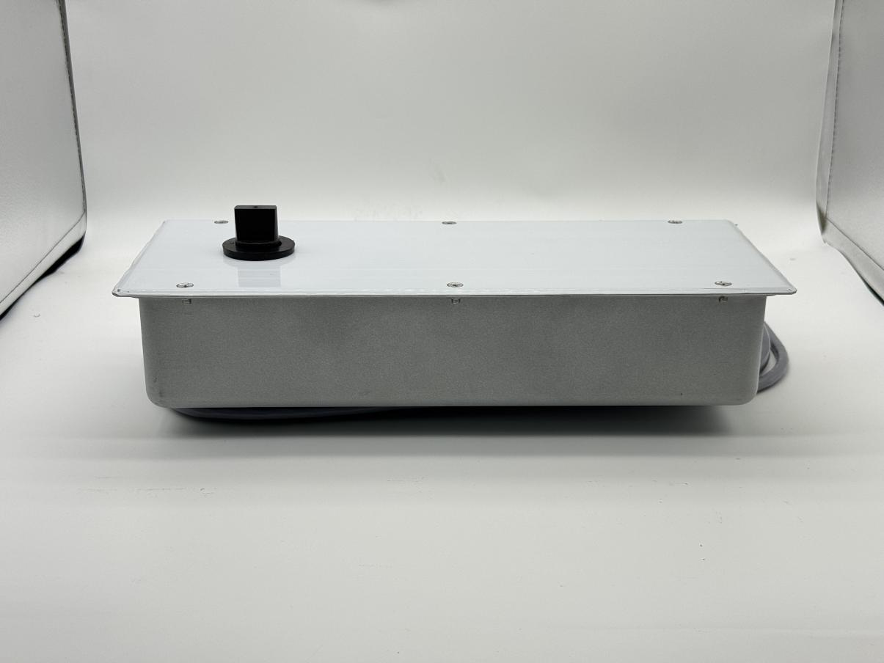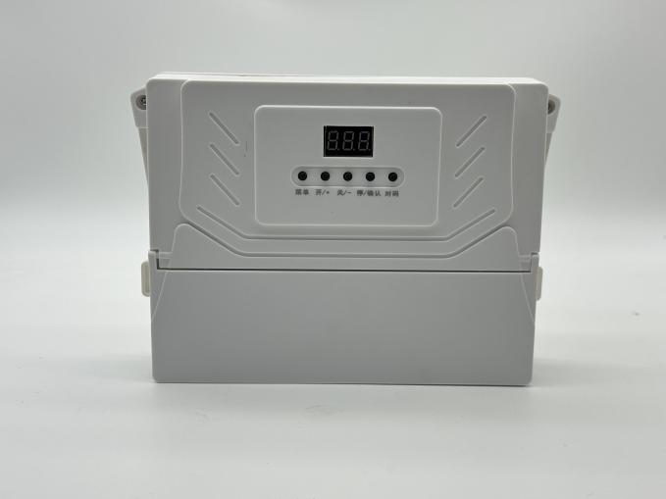
Specification of floor swing door operator
Item | Parameter | Remark
Working voltage | 220VAC±15% 50Hz
Motor operating voltage | 24VDC
Power of motor | 48W
Rated output torque | 56Nm
Angular speed | 48°/s
Maximum opening Angle | ±90°
Maximum length of door leaf | 1.2m (single door)
Maximum weight of door leaf | 250Kg
Thermal protection on motor winding | F Class 155℃
Operating frequency | Continuous running below 70℃
Operating ambient temperature | -25-70℃
Working environment | Indoor or sheltered outdoor environments
Running noise | ≤60dB
Temperature rise | ≤15℃
Weight of equipment packaging | 7.5kg
Body size (length * width * thickness) | 350*150*75mm
Packing size | 425×285×210mm

